Activity – 7:

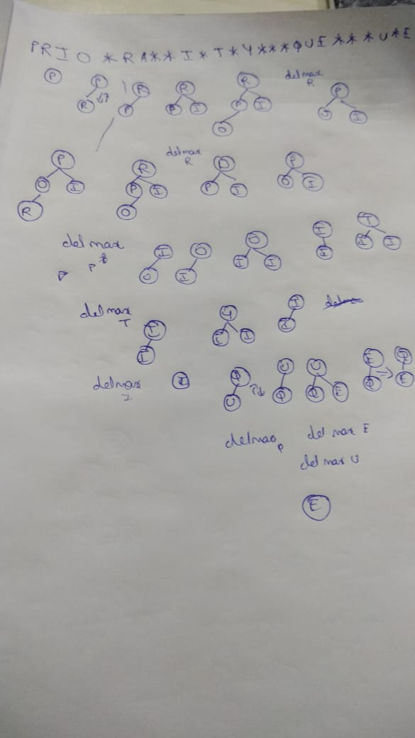

Activity – 8: if an array is in sorted order then its parent node will be always lesser and it is a min – oriented heap.